User Manual

Receiving files through SpecterX


About SpecterX
Enterprise Collaboration is vital for all business operations. It is key to reaching your business objectives, enabling remote work, and managing your partners, suppliers, customers, and even board communications.
However, as companies move towards cloud-based operations to enhance productivity, the control over their digital assets is diminishing, exposing sensitive data and intellectual property to potential security, privacy, and business risks. Regulatory requirements also mandate companies to keep a handle on their digital assets, but existing solutions often fall short.
SpecterX offers a solution. It keeps track of your data throughout its life cycle, irrespective of how many times it is shared or moved, both within or outside your organization. Our platform provides end-to-end visibility, full control, and comprehensive protection over data through a seamless user experience integrated with your existing tools. Our patented "Unified Driver" technology allows you to manage your data anywhere, with anyone, following your rules.

Receiving files through SpecterX
Files shared via SpecterX are secure and require authentication to gain access. When you open the email attachment or click on the ‘Open Attachments’ button, it will direct you to an access and authentication page.

Step 1: Open the email attachment
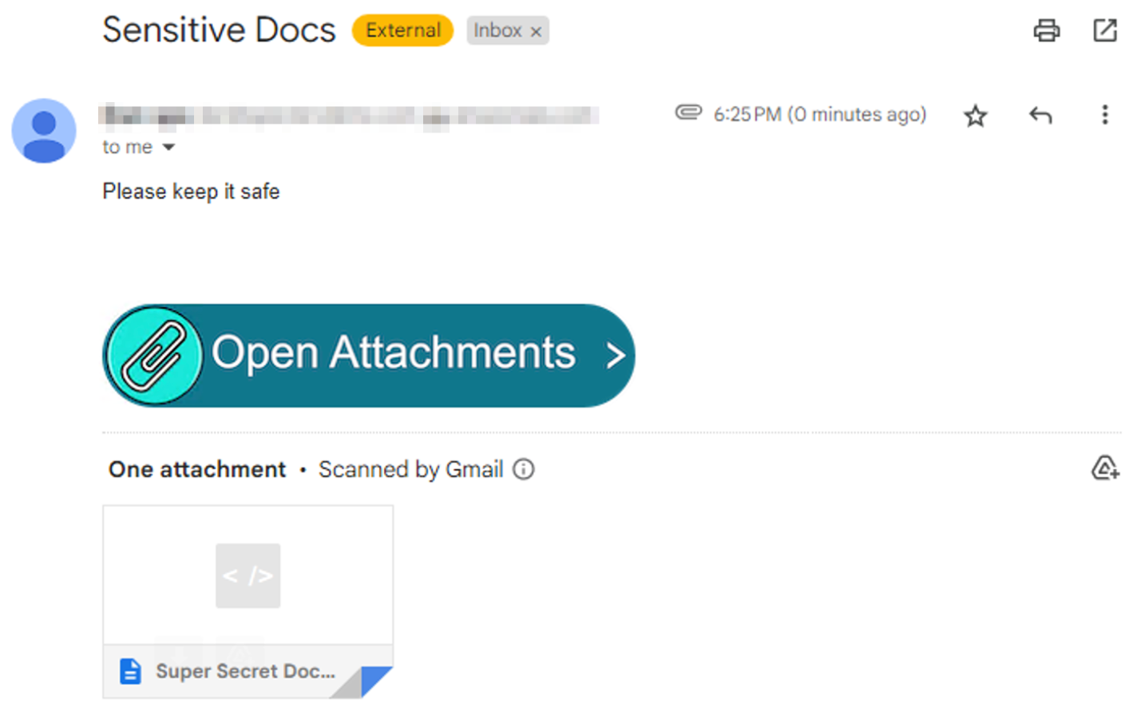
After opening the attachment or click on the ‘Open Attachments’ button, you’ll be presented with several options to access the data, each one accompanied by a list of its security policy characteristics.

Step 2: Choose how you want to access the file
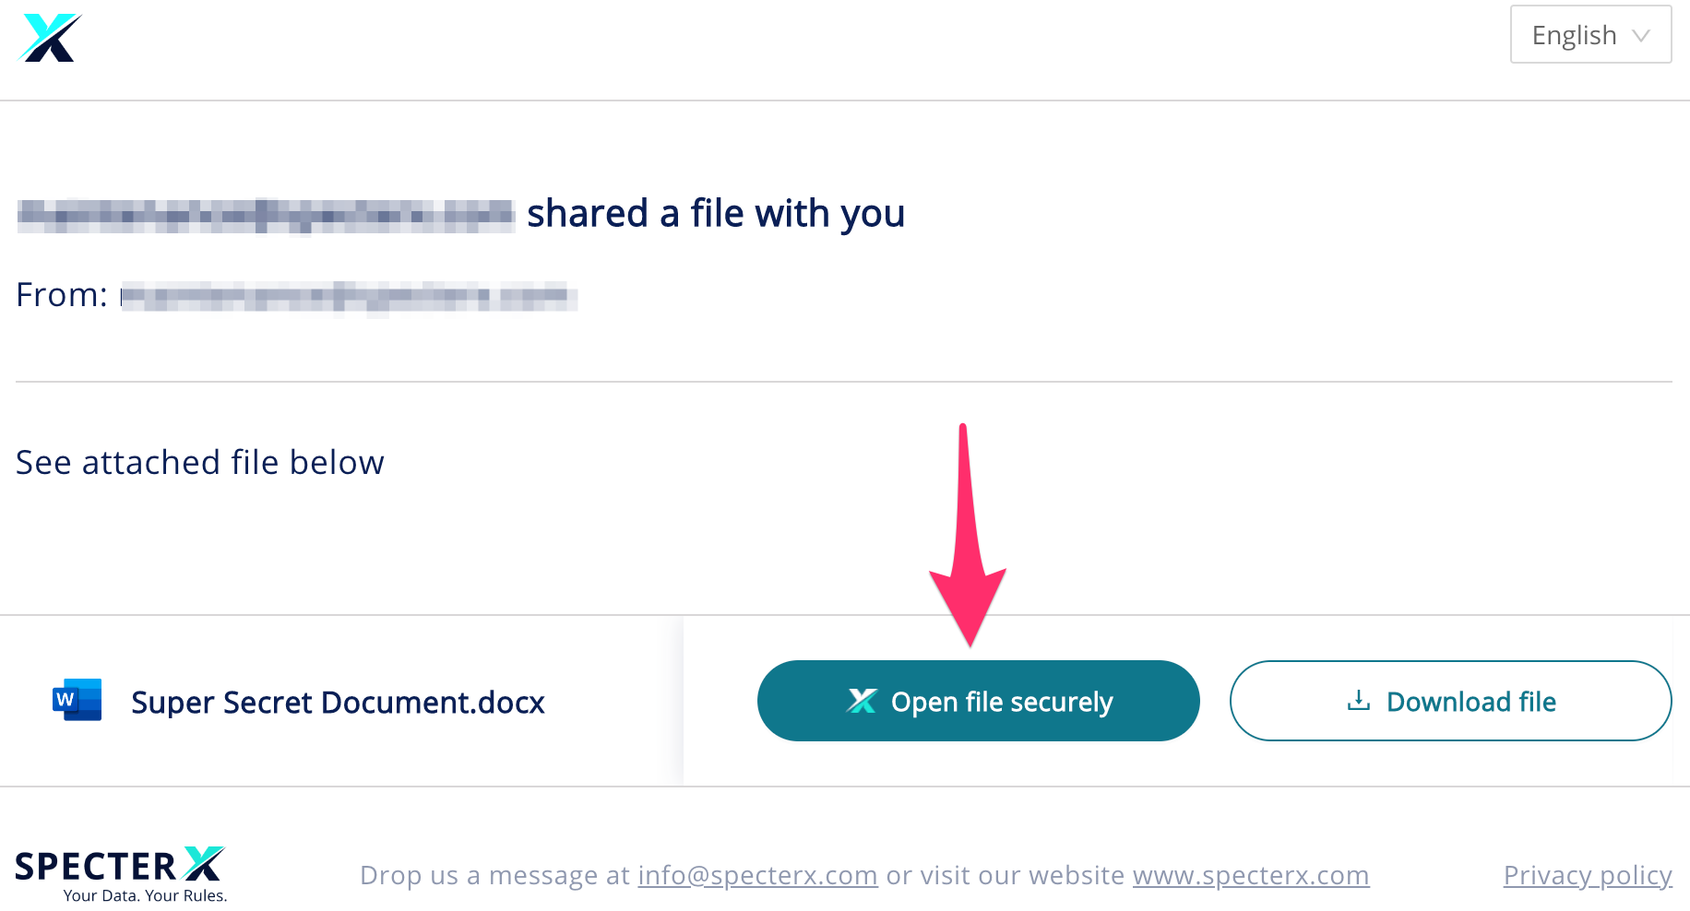

If this is your first time receiving files through SpecterX, the system will need to verify your identity. After choosing your preferred access option, you’ll get a one-time-code authentication.

In the email field, enter the email address to which you received the attachment.

Step 3: Enter email address and click ‘Send Code’
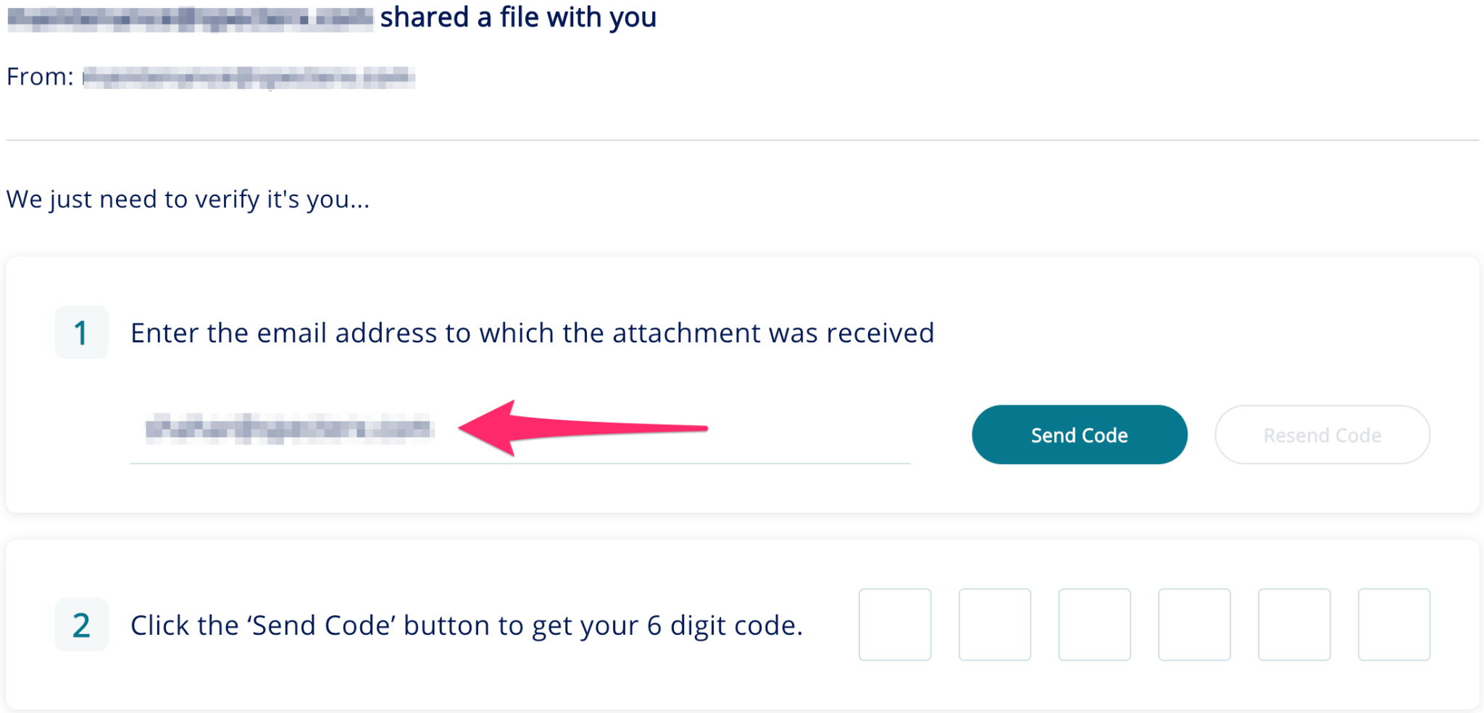

You will receive an email that looks like this:

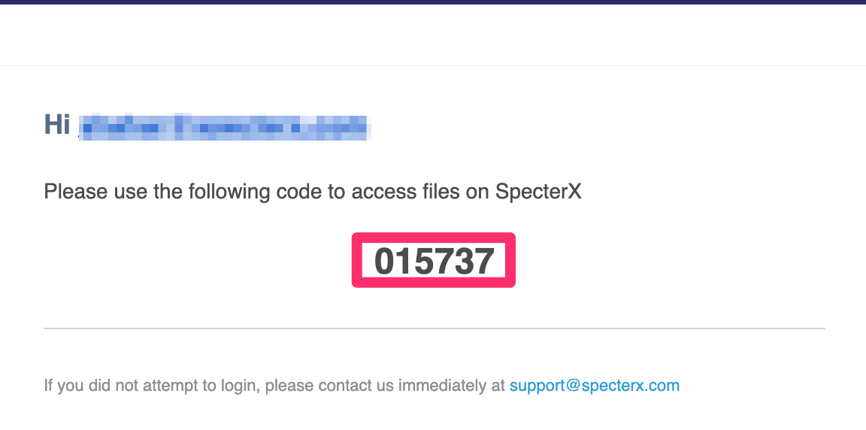

You can either copy-and-paste this code or enter it manually in the authentication screen.

Step 4: Enter the code
Enter the 6 digit code in the authentication screen

Step 4: Open or Download the shared file
- To open the file - click on the file name
- To download the file click on the ‘Download File Botton’

Step 5: View the file using SpecterX Secure Viewer
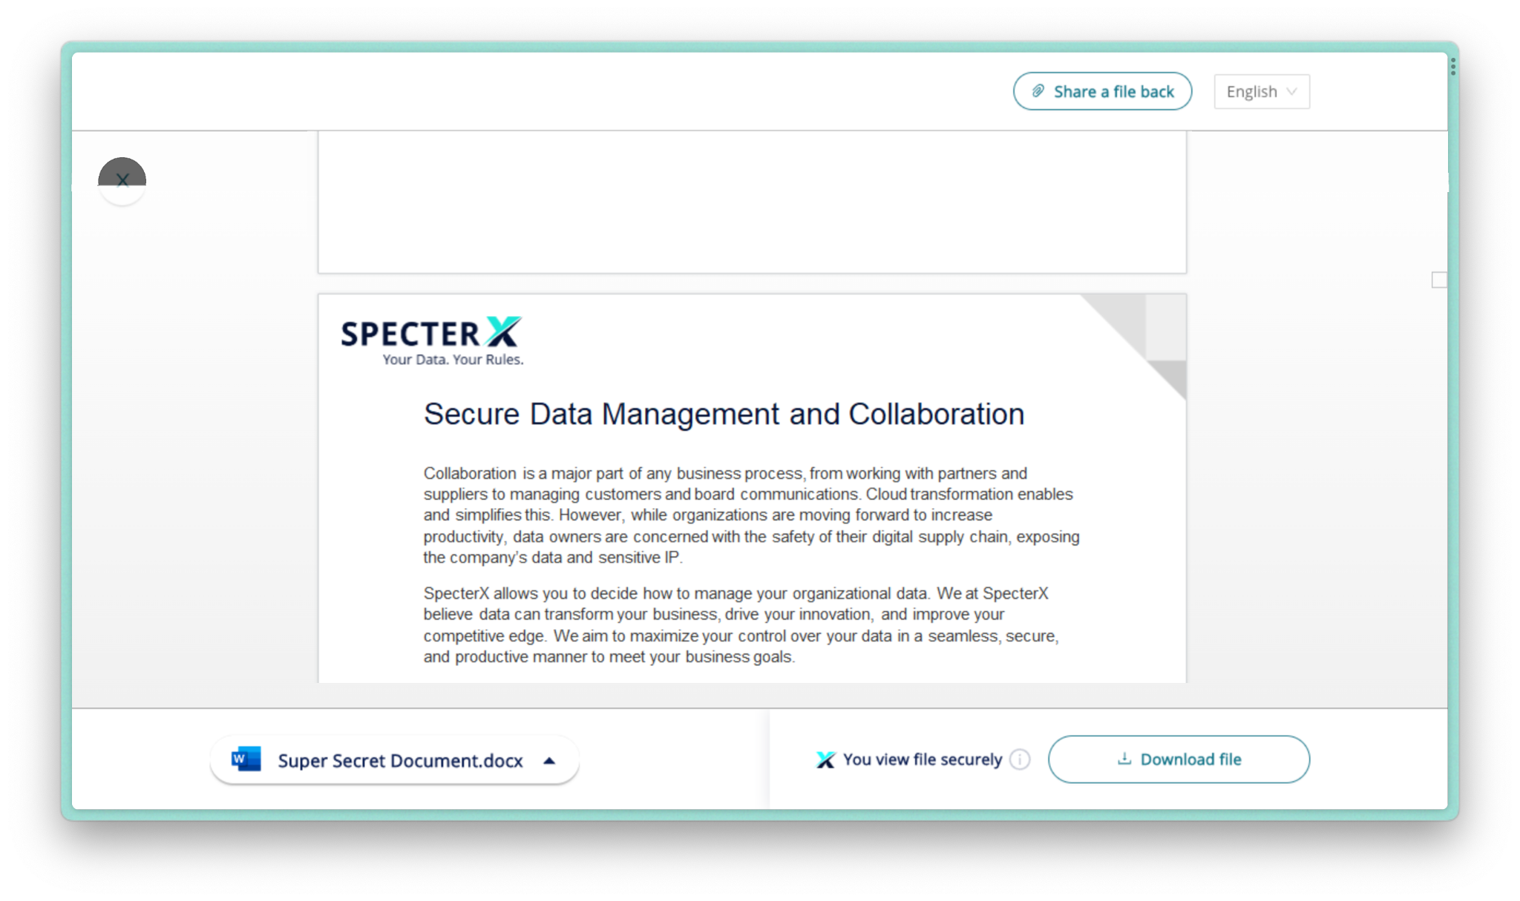
That’s it! You should now have access to the file.
Happy collaborating :)

If at any point you need assistance, our team is always glad to help.
Find us at: support@specterx.com

